GREEN KEY GLOBAL
A Hotel's Roadmap to Eco-Rating Certification
The Leading North American Standard in Sustainable Hospitality Certification
Why certification matters, how our program works, and how any property can get there
Published by Green Key Global | July 2026 | greenkeyglobal.com

Contents

The Case at a Glance
Sooner or later, every hotel gets asked the same question. A corporate travel buyer asks for a recognized sustainability certification before shortlisting the property. A booking platform asks for third-party verification before showing a sustainability badge. A brand adds certification to its standards. An owner asks why the utility bill keeps climbing.
It is always the same question underneath: can this hotel prove, credibly, how it operates? Green Key Eco-Rating certification is the most direct answer available to hotels in North America. We built it as hoteliers, for hoteliers, and it certifies operations rather than construction, which means any property can pursue it: full-service or select-service, downtown or roadside, luxury or economy.

Why this program, in five points
Built by the industry. Founded in 1993 and jointly owned by the American Hotel & Lodging Association and Hotels Canada, with more than 3,000 certified properties across North America.
No capital spend required to certify. The assessment scores what a property already does and recommends improvement over time.
A trusted benchmark. Aligned with all 17 UN Sustainable Development Goals, GSTC-Recognized, recognized by Travalyst, and verified by an independent third-party auditor.
A clear front door. Our 2026 Core Criteria define 37 mandatory questions as the path to a first Key, cutting average completion from about 80 days to about 11.
Priced for every tier. Published U.S. pricing works out to under $80 per month across a full three-year cycle.

The demand side is not theoretical. Travelers, meeting planners, and corporate buyers are actively filtering for certified properties, and the numbers below come from independent industry research.,,
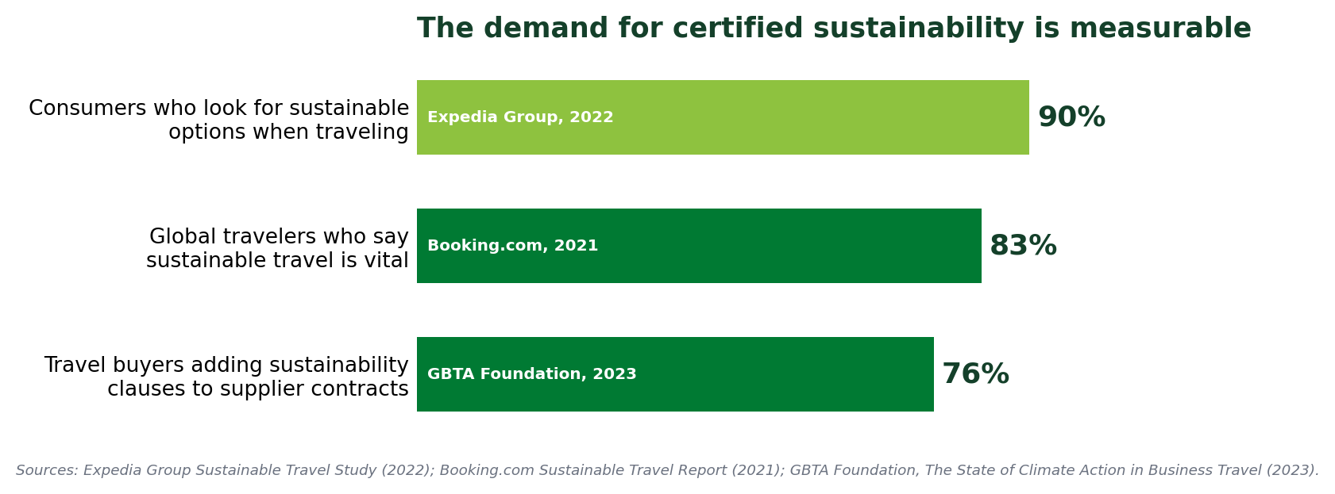

1. Who We Are
Green Key began in 1993, created by the Hotel Association of Canada (now Hotels Canada) as a certification designed from inside the industry. In 2024, the American Hotel & Lodging Association and Hotels Canada formed the joint venture that is Green Key Global today: the leading hotel sustainability certification program in North America.
The AHLA partnership tells you what the industry actually asked for. When AHLA surveyed the sustainability landscape, the feedback from hotels was consistent: one trusted certification, clear guidance, and operational standards, not another framework. Rather than build something new, AHLA joined the program that already had a thirty-year track record and was designed specifically for hotels.
That origin shapes everything about how our program works. Unlike building certifications, which measure how a structure was designed and constructed, Eco-Rating certifies how a hotel runs: daily practices, environmental management, guest experience, staff engagement, procurement, waste, water, energy, food and beverage, and meetings and events. A 1970s roadside property and a new-build lifestyle hotel compete on the same terms: the quality of their operating discipline.
Two design principles follow directly, and both matter to properties watching their budgets. First, no property is required to purchase HVAC systems, fixtures, or equipment to certify. The program evaluates existing practices, scores what already exists, and recommends improvements over time; capital upgrades are optional levers for a higher rating, never tickets to entry. Second, sections that do not apply, such as Food & Beverage or Conference facilities at a select-service property, can be opted out of entirely, and the scoring rescales so the property is not penalized.
One more detail about who we are: in partnership with One Tree Planted, a tree is planted for every new member, with more than 13,000 trees planted since 2023.

2. A Standard the World Recognizes
Our Eco-Rating program is aligned with all 17 United Nations Sustainable Development Goals, the shared global blueprint adopted by every UN member state in 2015. Appendix A lists all seventeen and shows how everyday hotel operations connect to each. The SDGs matter for a practical reason: they are the shared vocabulary of corporate sustainability, so an SDG-aligned certification lets a hotel answer buyer and RFP questions in the language they were asked in.
Around that core sits the set of independent recognitions that answer "says who?" when a third party checks. The Eco-Rating standard holds GSTC-Recognized status from the Global Sustainable Tourism Council. Our program is recognized by Travalyst, the independent coalition that works with major booking and travel platforms to bring consistency to accommodation sustainability labels. And the certification process is structured around ISO/IEC 17065, the international standard for certification bodies, alongside ISO 14001 environmental management principles.
Regulation is moving the same direction. The EU's Empowering Consumers for the Green Transition Directive, in force from September 2026, sets a legal floor for any sustainability label shown to European travelers: transparent access, independent verification, and a real mechanism to withdraw a label when a property stops complying. Our published compliance, suspension, and revocation policy is exactly that architecture, already in place.

Where Eco-Rating sits in the wider landscape
The rest of the industry is converging on the same model. The World Travel & Tourism Council's Hotel Sustainability Basics, a 12-action entry framework adopted by more than 8,000 hotels in 85 countries, announced in June 2026 that it is transitioning into an independent third-party certification scheme aligned with the same EU directive and the GSTC Accreditation Framework.,
Advisory firms are telling owners the same thing. JLL's framework for existing hotel assets argues that sustainability now runs through three steps: align goals with business objectives, build a credible data foundation, and turn that data into a funded strategy embedded in capital planning, because the payoffs (lower operating costs, green financing access, brand equity, lower regulatory risk) are already being realized by hotels that act.
For a North American hotel, the takeaway is simple. Independent, evidence-based certification is where the entire industry is heading. Eco-Rating is that model built specifically for this market, with a comprehensive operational assessment and a two-decade head start with the buyers who matter here.
 | Green Key Eco-Rating | WTTC Hotel Sustainability Basics
Scope | Comprehensive: 200+ operational questions across five hotel departments | Entry-level: 12 fundamental actions
Depth of rating | Graduated 1 to 5 Keys, room to grow for a decade | Verified baseline (phased over 3 years)
Market focus | North America; OTA, RFP, and brand integration here | Global framework
Governance | Owned by AHLA and Hotels Canada; independent audit by Control Union | WTTC initiative; verification partners; certification transition underway
Recognition | GSTC-Recognized standard; Travalyst; SDG-aligned | Aligning to GSTC Accreditation Framework and EU rules
The two programs are complementary rather than competing: Basics defines a global floor, while Eco-Rating provides the comprehensive, North America-focused certification a property can grow with.

3. The Business Case
We built this program around business outcomes: revenue, cost, operations, risk, and marketing. The math is plain. For most properties, three extra bookings in a year covers the cost of certification; every booking after that is positive return.

Revenue
Certification feeds OTA visibility and sustainability listings, and satisfies the certification requirements appearing in corporate RFPs and travel-program sourcing criteria. Independent research shows why buyers are filtering this way: 90% of consumers look for sustainable options when traveling, 83% of global travelers say sustainable travel is vital, and 76% of travel buyers are adding sustainability clauses to supplier contracts. Expedia's research has also linked certification to guest satisfaction, reporting a 15% increase in positive guest reviews at certified luxury properties.
The newest evidence comes from our 2026 partnership with the Alō Index, which scores hotel sustainability for corporate travel programs. Across 5,082 hotels assessed by Alō in 2025, certified properties averaged three times the corporate room nights of non-certified properties, and 97% of certified hotels won corporate business versus 70% of non-certified hotels.
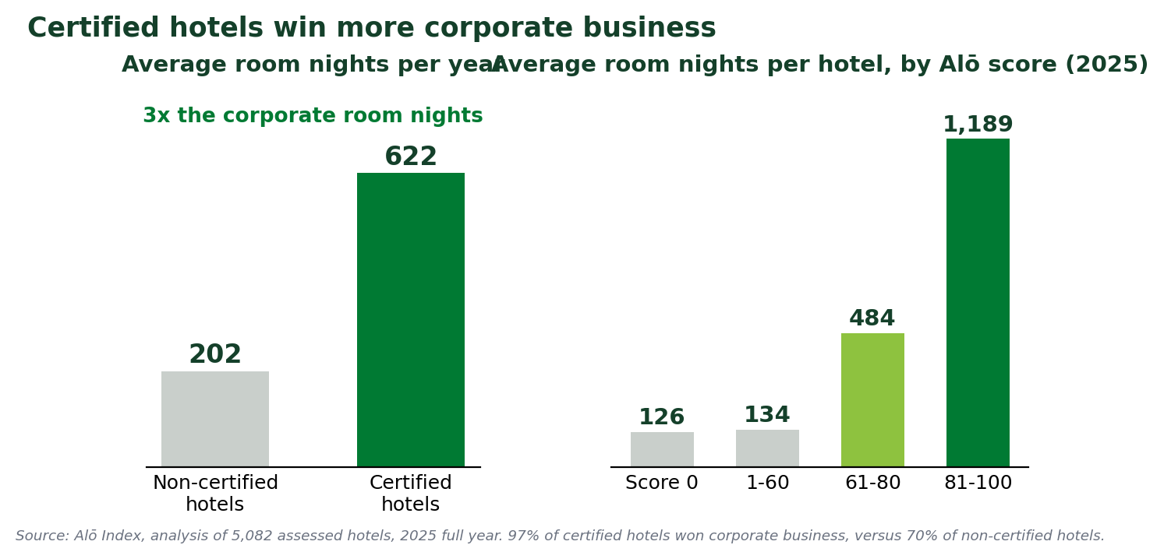

Cost, risk, and asset value
The practices the assessment rewards are the same practices that cut spend: metering utilities, preventative maintenance, sealing the building envelope, efficient lighting, water-wise housekeeping, right-sized food purchasing. The assessment is largely not asking a hotel to spend money on sustainability; it is asking it to stop spending money on waste.
On the asset side, JLL's analysis of existing hotel assets reaches the same conclusion from the owner's chair: hotels that embed sustainability into capital planning see reduced operating costs, improved access to green financing, enhanced brand equity, and lower regulatory and reputational exposure, and these gains are already being realized by hotels that have acted.

Operations and people
Certification also installs an operating framework: written policies, a cross-departmental Green Team, documented training, tracked data. Staff see their daily habits measured and recognized rather than merely suggested, and the Green Team tends to become a place where a room attendant and a chief engineer solve problems together.

4. Inside the Assessment: Five Key Performance Areas
The Eco-Rating self-assessment contains more than 200 questions organized into five Key Performance Areas that map onto how a hotel actually runs. Rather than grouping questions by abstract environmental theme, we organize them by department, so each section lands with the person who already owns the answers.
Key Performance Area | What It Covers | Applies To
Corporate Environmental Management | Governance and policy: sustainability policy, action plan, responsible purchasing, Green Team, staff and guest engagement, community involvement | All properties
Housekeeping | Daily practice in guest rooms and back of house: linen reuse, cleaning products, energy- and water-conscious routines, training | All properties
Engineering | Utilities and the building: energy and water tracking, preventative maintenance, HVAC, insulation, lighting, fixtures, waste, renewables | All properties
Food & Beverage Operations | Kitchen and dining: purchasing, food waste reduction and diversion, refrigeration monitoring, service practices | Optional; opt out if not applicable
Conference & Meeting Facilities | Event-space sustainability practices for properties marketing meeting space | Optional; opt out if not applicable

Every question follows the same learnable format: multiple-choice answers reflecting actual practice, clearly flagged mandatory items with links to downloadable templates, tips pointing to resources, glossary links for defined terms, and a notes field for context. Many questions score on graduated percentage tiers, so partial progress counts and improvement between cycles is visible.
Where documentation is required, the portal collects the upload against the question. That is what allows the audit to verify evidence rather than take assertions on faith, and it is why the durable preparation strategy is to build real systems: real utility tracking, real policies, real training. We periodically revise the criteria with input from subject-matter experts and hotel representatives, so systems outlast any particular version of the questions.

5. The Core Criteria: A Clear Front Door
In early 2026, we defined the program's baseline: the 37 mandatory questions within the Eco-Rating assessment that constitute the minimum requirement for a 1-Key certification. A "Display Core Criteria Only" filter at the top of each section isolates them, and members who meet the Core Criteria may qualify directly for the audit phase or keep answering questions to pursue a higher rating.
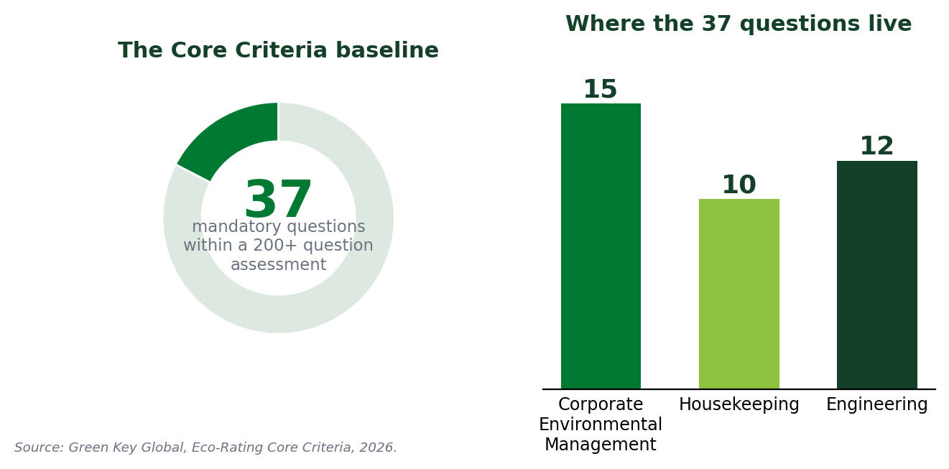
The problem this solves is familiar. A comprehensive assessment is credible but intimidating, and properties starting out would open the full question set and stall. Defining the baseline changed the math: average completion time fell from about 80 days to about 11, and the focused assessment itself takes roughly 4 to 6 hours of work.
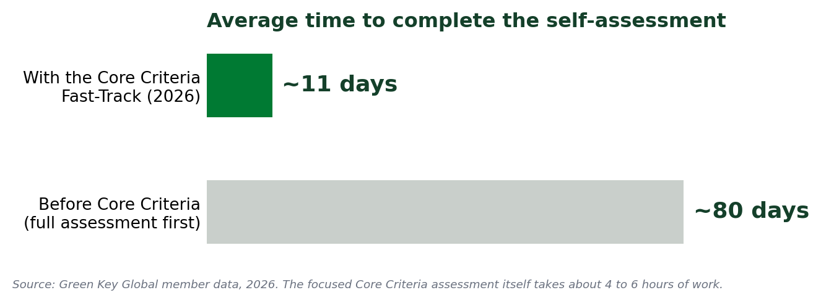
We did not choose the Core Criteria to be easy; we chose them to be foundational. Read as a set, they describe the minimum architecture of a genuinely managed program.
What the 37 mandatory questions require, in plain terms
Govern it. A written sustainability policy signed by a senior officer, with a named accountable manager, communicated to the whole team, plus a management action plan reviewed within the past year.
Buy responsibly. A written purchasing policy prioritizing local sourcing, recycled content, eco-friendly products, and certified responsible suppliers.
Staff it. A Green Team with a written, management-backed mandate that meets at least quarterly.
Train for it. A guest linen and towel reuse program; standard thermostat set-points; housekeepers trained on natural light, blinds, closed windows and doors, switching off unoccupied rooms, minimizing water, and reporting faulty equipment; safe handling of cleaning and medical waste.
Measure it. Annual electricity, gas, and water use and cost tracked with documentation; a written preventative maintenance program; scheduled HVAC checks; baseline insulation and window coverings; efficient outdoor lighting; efficiency considered in equipment purchases; honest reporting of low-flow fixture coverage.
Prove it. Mandatory answers only count with evidence uploaded. We provide templates for every required document.

That evidence requirement is the whole point. Under ISO/IEC 17065, a credible certification cannot rest on a hotel's word alone; it has to show its work. The Core Criteria answer the question of what the least a hotel can do and still deserve a credential that a regulator, a booking platform, and a corporate buyer will trust. The answer: govern it, staff it, train for it, measure it, and prove it.

6. How Certification Works
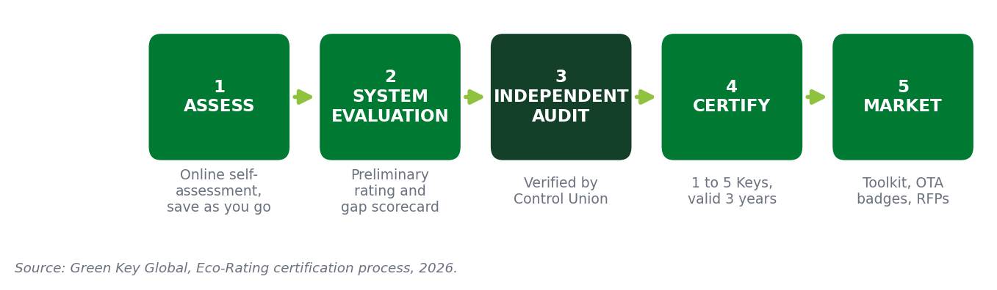
The journey is self-paced up front and rigorous at the back. A property registers through our Members Area and completes the online self-assessment, which can be worked across multiple sessions and users, with progress saved as you go. The platform then calculates a preliminary rating with a scorecard of strengths and gaps. The assessment can be retaken as many times as needed before an audit is requested, and the preliminary rating may not be represented publicly as certification.
When the property is ready, it resubmits, passes a pre-audit completeness check, pays the audit fee, and enters the queue for a virtual or on-site audit. At that point the assessment locks. We target commencing the audit process within about 90 days of the request, with at least one week's notice for on-site inspections. Rescheduling a confirmed virtual audit requires three business days' notice; on-site audits require twenty.

Who does what, and why it matters
Role | Responsibility
Green Key Global (Scheme Owner) | We develop the standard, define the rules and rating levels, own the mark, and provide templates, training, and member support. We do not audit hotels, which keeps the standard-setter impartial.
Control Union (Audit Body) | An independent global certification and inspection firm. Auditors review evidence, verify answers, and record findings. Under ISO/IEC 17065, the auditing function is prohibited from consulting to help a property pass.
Certification Body | The independent decision-making function with sole authority to grant, maintain, suspend, or withdraw certification, based on the criteria, the assessment, the evidence, and the audit findings.
Control Union: independent third-party certification and inspection services.
Successful properties receive a certificate and a rating of one to five Keys, valid for three years, along with a Property Performance Report identifying accomplishments and specific recommendations.
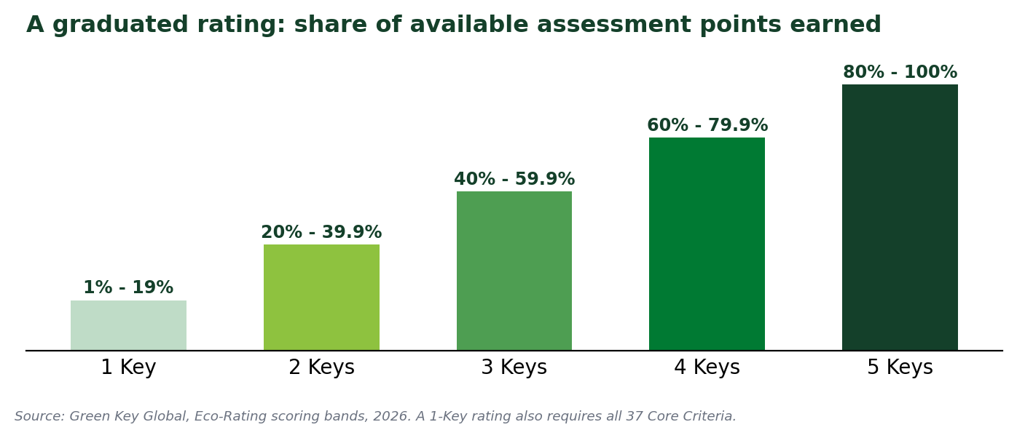
Any rating from 1 to 5 Keys is full certification; higher Keys reflect a higher share of available points, which a property builds toward over subsequent cycles. Members renew membership annually and receive an updated certificate each year; at the end of three years the property recertifies with a fresh assessment and audit against the then-current criteria. A property that stops meeting requirements is subject to corrective action, suspension, or revocation under our published compliance policy. That is not fine print; a label that can never be withdrawn is not a certification.

7. What It Costs
Our pricing is flat and published, which is itself part of the accessibility story: a percentage-of-revenue model would price the top of the market differently from the bottom. Published pricing as of July 2026:
Item | United States | Canada
Annual membership (per property) | $750 / year | $950 CAD / year
Virtual audit (once per 3-year cycle) | $500 | $500
On-site audit (optional alternative) | $2,500* | $2,500*
Additional audits (if required) | $500 | $500
*On-site audit pricing depends on travel costs. Fees are non-refundable except in exceptional circumstances. Fees are reviewed periodically; current pricing is always available at greenkeyglobal.com.
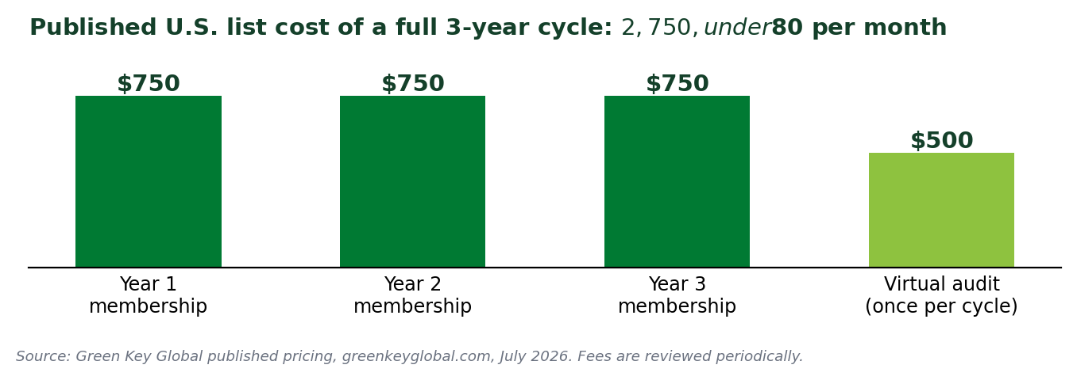
Against a single corporate RFP won, one OTA-badge booking lift, or a small percentage off a utility bill, the fee is not the decision variable. The decision variable is internal effort, and the Core Criteria redesign was built to compress exactly that.
List pricing is also the ceiling, not the expectation, for groups. Our growth runs through portfolio relationships: Master Services Agreements with brands and Memorandums of Understanding with management companies, the vehicles through which brands and management groups enroll properties at scale, with negotiated per-property rates, coordinated onboarding, and fast-track pathways that credit work already done under brand programs. Destination organizations add a third dynamic: a growing list of cities and DMOs sponsor or incentivize certification across their markets. If your property flies a flag or sits in a managed portfolio, check with us for an existing agreement before enrolling individually.

8. The Vendor Ecosystem
A certification standard naturally creates demand for products and services that help properties meet it, and we manage that dynamic transparently. Our Vendor Program is a curated network of sustainability-focused suppliers, published through the Green Vendor Directory of more than 75 vetted providers, with member hotels eligible for exclusive discounts from select vendors.
The ground rules are the important part. The Vendor Program is explicitly not a certification: we do not certify, verify, or endorse vendors, we make a vendor-agnostic promise that no supplier is recommended over another, and we run no lead-generation or referral service. Vendors pay for visibility, at an Approved tier ($500 per year, self-serve directory listing) or a Preferred tier ($2,000 per year, adding co-marketing support), with discounts for AHLA and Hotels Canada partners. The auditor deciding a property's rating has no stake in what the property buys.
For hotels, the value runs the other way: when the assessment surfaces a gap, whether eco-certified cleaning products, recycled-content supplies, EV charging, or waste diversion, the directory is a pre-filtered starting list of suppliers who already serve certified hotels. Strategic partnerships such as the Alō Index sit above the vendor program, extending what the certification is worth commercially after it is earned.

9. After You're Certified
Certification is the point where a property holds a documented, third-party-verified baseline and a three-year roadmap. Each certified property receives its rating and certificate (or personalized plaque), a Property Performance Report with property-specific recommendations, and access to our Marketing Toolkit: website copy and logos, in-room and meeting-space materials, traveler-facing collateral, RFP response content, department-level staff checklists, and case-study and social promotion opportunities.
Distribution does part of the work automatically: we share lists of certified properties with OTAs, government procurement officers, and RFP platforms on an automated basis, so travelers and planners can see certified properties on the channels where they book.
The Property Performance Report deserves a highlight. Because ratings are percentage-based, the report shows which categories hold the points that would move the property into the next Key tier, which turns "improve our rating" into an assignable list. The pattern that works best: reach 1 Key through the Core Criteria first, then use the report to plan a deliberate climb, concentrating any capital spend where it pays twice, once in utilities and once in rating.
The claims-use rules are a feature, not a burden. Members may use the Green Key name, rating, and logos only while certification is current and within scope, and must keep website and booking-platform displays accurate. Those guardrails are what keep the credential meaningful in market, and what keep a property's sustainability marketing on the right side of tightening green-claims regulation.

10. Getting Started on Property
The biggest predictor of a smooth certification is what a property does before answering question one. The sequence below fits comfortably inside 90 days, and properties with strong existing practices compress it further.
Phase | What Happens
Days 1 to 30: Foundation | Name the accountable senior officer. Form the Green Team with a written mandate and quarterly meetings on the calendar. Request 12 months of utility invoices (electricity, gas, water). Download our templates for the sustainability policy, action plan, purchasing policy, and Green Team mandate.
Days 31 to 60: Close the gaps | Launch the linen and towel reuse program if it does not exist. Put the preventative maintenance program in writing. Standardize thermostat set-points and add the trained behaviors to housekeeping checklists. Finalize and sign the purchasing policy. Start (or document) fixture coverage and any F&B monitoring logs.
Days 61 to 90: Assess and request audit | Complete the self-assessment using the Core Criteria filter first. Upload every required document. Run a cross-department consistency check, because the assessment locks once the audit is requested. Choose virtual or on-site audit and request it through the Members Area.

What each department will be asked to do
Most of the work lands as small, specific changes to routines that supervisors already run. Nothing below requires a budget line to start.
Team | Day-to-day contribution
Housekeeping | Run the linen reuse program. Clean by natural light where possible, manage blinds with heating and cooling needs, keep windows and doors closed while systems run, switch off lights and TVs in empty rooms, minimize water while cleaning, and report faulty equipment right away.
Engineering / Maintenance | Keep utility bills organized and tracked. Follow the written preventative maintenance schedule for HVAC, ventilation, plumbing, and lighting. Log fixture coverage and any efficiency upgrades.
Front Office / Admin | Email guest folios instead of printing. Default to double-sided printing. Help communicate the sustainability policy to staff and guests.
Food & Beverage (if applicable) | Keep freezer and thawing logs. Practice first-in-first-out and right-sized ordering. Separate organics where service exists and log any surplus food donations.
General Manager | Sign and endorse the policy, sponsor the Green Team, and keep the quarterly meeting cadence real, because the audit checks for evidence of meetings, not just a signed document.

The close of the case is the simplest part. We never ask a property to be something it is not. We ask a hotel to run well, prove it, and be recognized for it: by a standard hoteliers built, anchored to goals the whole world has agreed on, verified by an auditor no one can lean on, at a price every tier of the market can carry. It is the rare initiative that the owner, the chief engineer, the sales director, and the housekeeper can all read as their own.
Ready to start? Visit greenkeyglobal.com or contact our Member Services team at info@greenkeyglobal.com.

Appendix A: The 17 UN Sustainable Development Goals
Adopted by all United Nations member states in 2015, the Sustainable Development Goals are a shared blueprint for people and planet through 2030. Our Eco-Rating program is aligned with all seventeen. The right column shows how ordinary hotel operations connect to each goal.
Goal | Name | How a hotel contributes
01 | No Poverty | Hotel jobs and local purchasing keep income in the communities where properties operate.
02 | Zero Hunger | Food waste reduction and surplus food donation put edible food to use instead of landfill.
03 | Good Health and Well-Being | Safer cleaning products, air quality, and proper hazardous waste handling protect guests and staff.
04 | Quality Education | Staff sustainability training builds transferable skills across every department.
05 | Gender Equality | Hospitality is a major employer of women; equitable practice turns jobs into careers.
06 | Clean Water and Sanitation | Guestroom fixtures, laundry programs, and kitchen practice conserve a shared community resource.
07 | Affordable and Clean Energy | Tracking and reducing energy use lowers cost and the emissions tied to it.
08 | Decent Work and Economic Growth | Local sourcing and fair, stable hospitality employment strengthen the tourism economy.
09 | Industry, Innovation and Infrastructure | Efficient building systems modernize a property while cutting resource use.
10 | Reduced Inequalities | Sustainable tourism brings investment and opportunity to overlooked communities.
11 | Sustainable Cities and Communities | Hotels are part of the built fabric of their cities and towns.
12 | Responsible Consumption and Production | Responsible purchasing, eco-friendly products, and waste reduction in daily operation.
13 | Climate Action | Every kWh and therm avoided is a direct, measurable contribution.
14 | Life Below Water | Coastal and island properties depend on the healthy oceans that sustain their tourism.
15 | Life on Land | Conserving resources and supporting biodiversity protects ecosystems on and around property.
16 | Peace, Justice and Strong Institutions | Written policies, accountable officers, and documented plans are governance in practice.
17 | Partnerships for the Goals | Our organization is itself a partnership between AHLA and Hotels Canada.

Four operational areas do an outsized share of the work, and map most directly as follows: Energy advances SDG 7 and SDG 13; Water advances SDG 6; Food Waste advances SDG 2 and SDG 12; Procurement advances SDG 8 and SDG 12.

Appendix B: Glossary
Term | Plain-language meaning
Core Criteria | The 37 mandatory questions that form the baseline for a 1-Key certification.
Key Performance Area (KPA) | One of the five sections of the assessment: Corporate, Housekeeping, Engineering, Food & Beverage, Conference & Meeting Facilities.
Scheme Owner | The organization that develops a certification standard and owns its rules and mark, but does not certify properties itself. Green Key Global is the Scheme Owner.
Certification Body | The independent function that makes the final certification decision and issues certificates.
Audit Body / Control Union | The independent third-party firm that conducts audits on behalf of the Certification Body.
ISO/IEC 17065 | The international standard governing how certification bodies must operate: impartial, competent, and consistent.
ISO 14001 | The international standard for environmental management systems.
GSTC | Global Sustainable Tourism Council, the accreditation body for sustainable tourism standards; Eco-Rating is a GSTC-Recognized standard.
Travalyst | An independent sustainable-travel coalition working with major booking platforms to bring consistency to sustainability labels.
Green Team | The mandatory cross-departmental group that directs a property's environmental initiatives, with a written mandate and quarterly meetings.
MSA / MOU | Master Services Agreement (brands) and Memorandum of Understanding (management companies): the portfolio-level agreements through which groups enroll at negotiated terms.
OTA | Online Travel Agency, such as Booking.com or Expedia.
Property Performance Report | The report issued with certification, detailing results and specific recommendations for improving the rating.
Sub-metering | Separate meters on specific systems or areas so consumption can be tracked in detail.

Appendix C: Third-Party References and Further Reading
United Nations. Transforming Our World: the 2030 Agenda for Sustainable Development (2015): sdgs.un.org.
Global Sustainable Tourism Council. GSTC-Recognized Standards for Hotels: gstc.org.
Travalyst. Industry framework for accommodation sustainability across major travel platforms: travalyst.org/industry.
European Union. Directive (EU) 2024/825 on Empowering Consumers for the Green Transition.
World Travel & Tourism Council. Hotel Sustainability Basics: wttc.org/initiatives/hotel-sustainability-basics. Press release, WTTC Elevates Hotel Sustainability Basics to Independent Global Certification Scheme (25 June 2026): wttc.org/news.
JLL. Greener returns: A framework for operationalizing sustainability in existing hotel assets (18 November 2025): jll.com.
Expedia Group. Sustainable Travel Study (2022).
Booking.com. Sustainable Travel Report (2021).
GBTA Foundation. The State of Climate Action in Business Travel (2023).
Alō Index. Analysis of 5,082 assessed hotels, 2025 full year.
Control Union. Independent certification and inspection services: controlunion.com.
One Tree Planted. onetreeplanted.org.
Program details, criteria, and fees are reviewed and updated periodically. Current specifics are always available at greenkeyglobal.com or from our Member Services team.

Expedia Group, Sustainable Travel Study (2022).
Booking.com, Sustainable Travel Report (2021).
GBTA Foundation, The State of Climate Action in Business Travel (2023).
One Tree Planted. onetreeplanted.org.
United Nations, Transforming Our World: the 2030 Agenda for Sustainable Development (2015). sdgs.un.org.
Global Sustainable Tourism Council, GSTC-Recognized Standards for Hotels. gstc.org.
Travalyst, Industry: independent framework alignment for accommodation sustainability across major travel platforms. travalyst.org/industry.
ISO/IEC 17065:2012, Conformity assessment: Requirements for bodies certifying products, processes and services. iso.org.
Directive (EU) 2024/825 on Empowering Consumers for the Green Transition, entering into force 27 September 2026.
World Travel & Tourism Council, Hotel Sustainability Basics. wttc.org/initiatives/hotel-sustainability-basics.
WTTC, "WTTC Elevates Hotel Sustainability Basics to Independent Global Certification Scheme," 25 June 2026. wttc.org/news.
JLL, "Greener returns: A framework for operationalizing sustainability in existing hotel assets," 18 November 2025. jll.com.
Expedia Group, Sustainable Travel Study (2022).
Booking.com, Sustainable Travel Report (2021).
GBTA Foundation, The State of Climate Action in Business Travel (2023).
Expedia Group, Sustainable Travel Study (2022): certified properties and traveler review behavior.
Alō Index, analysis of 5,082 assessed hotels, 2025 full year.
JLL, "Greener returns: A framework for operationalizing sustainability in existing hotel assets," 18 November 2025. jll.com.
ISO/IEC 17065:2012, Conformity assessment: Requirements for bodies certifying products, processes and services. iso.org.
Control Union, independent global certification and inspection services. controlunion.com.
United Nations, Transforming Our World: the 2030 Agenda for Sustainable Development (2015). sdgs.un.org.

